**Teamwork Documentation – BATHS Part 2**  
**Module:** 5COM2007

**1. Communication Evidence**

**Period 1: 17/03/2025**

**Screenshot:**

**Description:** *Team discussion on task allocation for BATHS part 2*

**Period 2: 25/03/2025**

**Screenshot:**

**Description**:

Discussing potential GUI Challenge task implementation, and double checking everyone knows what they are doing

**Screenshot:**

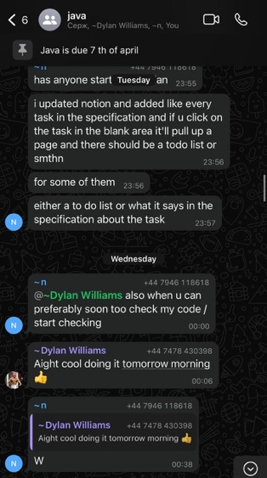

**Description:** Setting up the Notion for the team and starting the work/test workflow between teammates.

**Screenshot:**

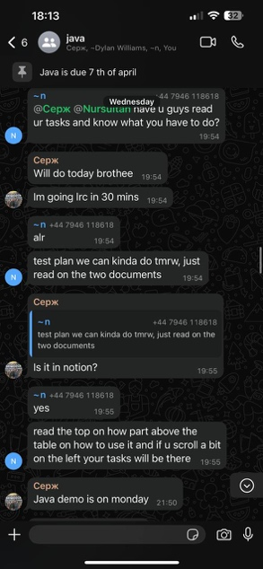

**Description:** Setting up a group meeting in library for mid-assignment questions.

**2. Kanban Board Progress**

**Period: 17/03/2024**

**Screenshot:**

**Description:**

Separate modules have been allocated to members to allow parallel development of different tasks within the assignment. Involving JUnit test creation, implementing classes based on the specification and documenting the progress. Certain programming tasks must be put under review to ensure it has been done correctly through this kanban board system.

**Period 2: 3/04/2024**

**Screenshot:**

**Description:**

This screenshot shows our team’s final stretches of the **structured task breakdown** for the BATHS project

**3. Version Control (Git) Contributions**

**Screenshot:**

**Description:**

Commits from all team members on initial setup and supplier classes

***DYLAN WILLIAMS****: J Units testing, Test Plan.*

***NAGLIS SLAMISKIS****: Ship classes and subclasses implementation, Fleet class, Classes Implementation.*

***SIROJIDDIN NAJMIDDINOV****: Logic enhancement, Project Documentation.*

***NURSULTAN ABDUAZIMOV****: Logic enhancement, Project Documentation.*